Project Design Phase-II Technology Stack (Architecture & Stack)

|  |  |
| --- | --- |
| **Team Members** | **Tony David Raj M Shankaresh R**  **Udaya Kiran S Shanjay V** |
| **Team ID** | **PNT2022TMID13856** |
| **Project Name** | **Inventory Management System for Retailers** |
| **Maximum Marks** | **4 Marks** |

**Technical Architecture:**

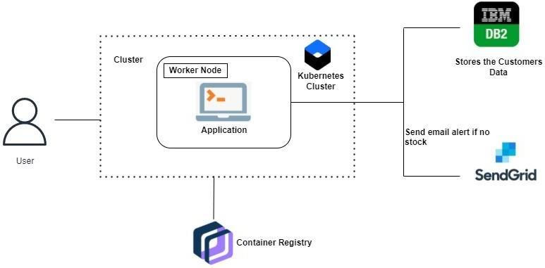

Components & Technologies:

|  |  |  |  |
| --- | --- | --- | --- |
| **S.**  **No** | **Component** | **Description** | **Technology** |
| 1. | User Interface | Web UI, Mobile App, Chatbot etc. | HTML, CSS, JavaScript, React JS |
| 2. | Application Logic - 1 | Alert retailers in case of low stock | Python - Flask, Sen |
| 3. | Application Logic - 2 | Chatbot for CRM | IBM Watson Assistant |
| 4. | Cloud Database | Database Service on Cloud | IBM DB2 |
| 5. | File Storage | File storage requirements | IBM Object Storage |
| 6. | Infrastructure (Server / Cloud) | Cloud Server Configuration | Local, Cloud Foundry, Kubernetes. |

Application Characteristics:

|  |  |  |  |
| --- | --- | --- | --- |
| **S.**  **No** | **Characteristics** | **Description** | **Technology** |
| 1. | Open-Source Frameworks | Used open-source frameworks for styling webpage and building web application | Python flask, Bootstrap |
| 2. | Security Implementations | To keep user data secure, verify ownership of the website, prevent attackers from creating a fake version of the site, and convey trust to users. | SSL, IBM Cloud security |
| 3. | Scalable Architecture | 3 – tier architecture MVC | Web server - HTML, CSS, JS  Application server  - Python Flask, Docker, Container Registry  Database server - IBM DB2 |
| 4. | Availability | To evenly distribute network traffic to prevent failure caused by overloading a particular resource | IBM Load Balancer |
| 5. | Performance | Use of local machine Cache memory | IBM Cloud, CDN |